**Poster Presentation: ScanPay App – A Seamless Shopping Experience**

**Project Overview:** ScanPay is a mobile application for users which has functionality to optimize the process of shopping to only include scanning barcodes for payments. It also offers an efficient way to cheque out in a retail store to eliminate long queues and further improve users’ convenience. By focusing on intensified usability and safe authorization, ScanPay has been developed as a response to the increase of consumers’ demand for quicker and more convenient and efficient payment methods: supermarkets and shopping malls mainly.

**Key Features:**

1. **Splash Screen:**

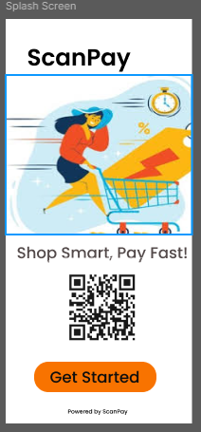

The minimalistic splash screen presents the app logo and a “Get Started” button. It means that the goal is to create an empty point of entry that will not bomb site visitors with too much information at once and will let them directly immerse into application experience.

1. **Login/Signup Screen:**

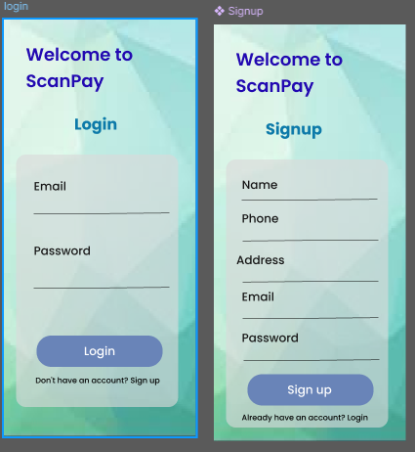

Login options make it easier for users and clients to access their areas by supporting login methods through email verification, social media accounts, and fingerprints scans. This feature’s sole purpose will be to ensure that it is easy for new and old users to sign into the app securely.

1. **Home Screen:**

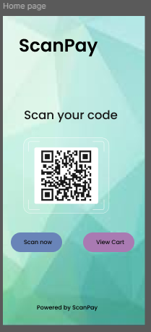

The home screen offers a simple and intuitive layout with two primary actions: “Scan Now” and “View Cart.” This avoids cluttering the page with features the user doesn’t need which would complicate usage of a particular program.

1. **Scan Now Screen:**

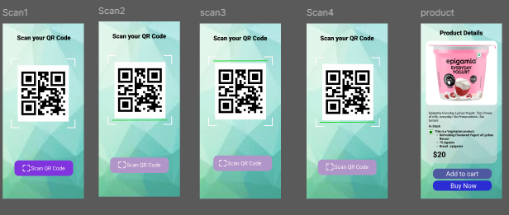

This area is the heart of the application: this is where the barcode scanner is located. Customers can run an item over the scanner to get information about the product such as the name of the product, the price and whether it is in stock or not. The options of either “Add to Cart” or “Buy Now” give the users the ability to select full tangible shopping preparedness depending on the users shopping intentions therefore the options benefit the users.

1. **Cart Screen:**

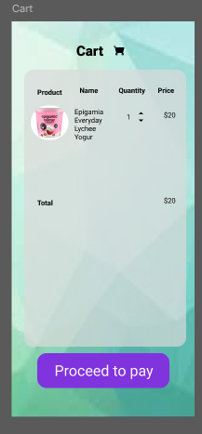

Temporarily, during the session, the used cart contains all products and their quantities together with the total cost. There is only one button that changes the context, and that “checkout” button takes the user from the cart cheque to the payment process.

1. **Payment Screen:**

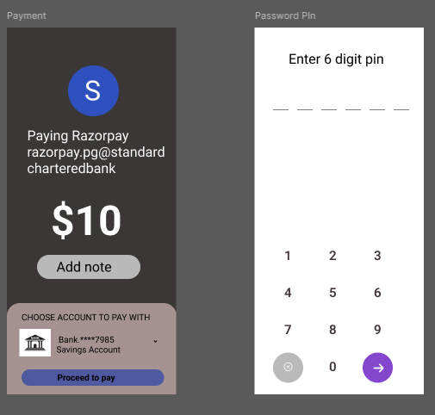

The payment options through payment gateways that help the users to make their payments safely. Credit card payment, digital wallet payment among others, variants of payment methods aligns with the user’s preference thus improving the app functionality.

1. **Confirmation Screen:**

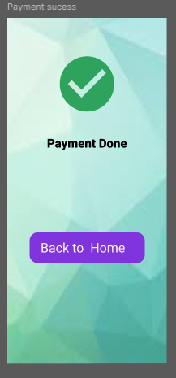

After payment has been processed, the user is taken through a confirmation of the purchase where details of the purchase, confirmation of the payment and the details of shipping are presented. This final screen is important for reuse since it offers users a record of their transaction to prevent them from having second thoughts about the performed action.

**User Flow & Design Rationale:**

The flow in the case of using ScanPay was made as fluid as possible in its layout as well as in its scheme. This is achieved with no cluttered screen and buttons that are easily seen and on create view holder with a clear and concise way of encouraging the user to make the next step. This project tries to acknowledge all the User-Centred Design (UCD) principles and bring progressive changes preferring an “easy to use” app with less cognitive load during the navigation process.

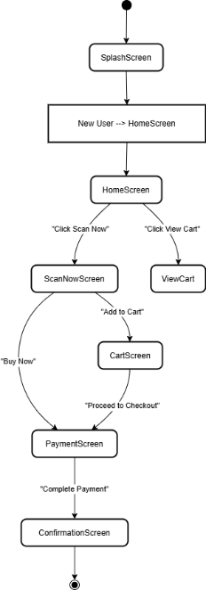

* **Splash Screen:** The splash screen needed to be quickly informative without bombarding the user with too much data, which the splash screen provides.
* **Login/Signup:** The several basic and safe authentication technologies meet diversified users’ needs, making them less annoyed when logging in.
* **Home Screen & Scan Now:** There are no problems with understanding the interface since it is designed in minimalist style emphasizing just two major features: barcode scanning and cart.
* **Cart & Payment:** The cart is arranged professionally in enabling customers to see products they have selected before proceeding to payment details. The integration of secure payment gateway provides a secured as well as an efficient transaction platform.
* **Confirmation:** The last order confirmation page provides a brief and relieves the users about their transaction process.

**User-Centered Design (UCD):**

ScanPay is a result of Apply User-Centred Design (UCD) as the needs and feedback of the users were the primary determinant of the design process. Cycles of feedback were applied; real users tried the prototypes to define what changes should be made. Usability testing made it possible to ensure that the navigation of the app was easy on devices to strengthen device operation. There is an iterative process of designing that was implemented to adjust the developed ScanPay toward the expectations.

**Key Findings from User Research:**

In the requirements-gathering phase, leaving clear instructions for further work, the design team of ScanPay studied the main concerns and preferences among the users. These findings served as the basis for designing the app core that successfully offers solutions to the users’ needs. They valued speed and accuracy of barcode scanning, and hence efficiency in scan utility. Finally, a reliable and conveniently oriented payment system with as many payment methods as possible is implemented to provide a clean cheque.

**Prototype Development Tools:**

Prototyping of ScanPay was designed using **Figma** to develop high-fidelity wireframes and interactive prototypes, while smooth transitions such as illustrations and animation were developed using **Adobe XD.** **Maze** was used for the purpose of usability testing to understand general user feedback about the application i.e. how well the application is meeting business requirements as well as the user requirements.

**Conclusion & Impact:**

ScanPay aims to transform the retail shopping experience with a fast, secure, and intuitive purchasing process. Owing to the clear lack of clutter and intuitive naturalist navigation of the app, its payment security and overall user flow, the issues of Shopping cart and its complexities involved specifically in supermarkets and retail stores are mostly resolved. Thus, operating as an application under the principle of a user-centered design, ScanPay optimizes the checkout process and makes it as smooth and convenient as possible. The focus of this poster is on the idea and concept of ScanPay, design considerations, and users for furthering the discussion of applications of mobile shopping applications.